7.6: a) (Denote the top of the ramp as point 2.) In Eq. (7.7), and taking 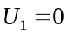 and or 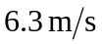 to two figures. Or, the work done by friction and the change in potential energy are both proportional to the distance the crate moves up the ramp, and so the initial speed is proportional to the square root of the distance up the ramp; 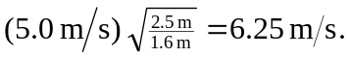
b) In part a), we calculated  and 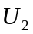. Using Eq. (7.7),
